Table Of Contents
1.Introduction
2.Organization/Institution Background
2.1 Name and Type of Organization
2.2 Main Activities
2.3 Department Where the Problem Exists
2.4 Current Method Used
3. Problem Statement
3.1 The Existing Problem
3.2 Causes of the Problem
3.3 Effects of the Problem
3.4 People Affected
3.5 Why a Software Solution Is Necessary
4. Proposed Solution
4.1 System Name
4.2 Purpose of the System
4.3 Target Users
4.4 Major Features
4.5 Expected Benefits
5. Functional and Non-Functional Requirements
5.1 Functional Requirements
5.2 Non-Functional Requirements
6. Dart Source Code
7. Screenshots/Output of the Dart Program
8. Brief Explanation of the Program
9. GitHub Repository
10. Conclusion
11. References

INTRODUCTION
Many private secondary schools in Sierra Leone depend on school fees to pay teachers and run daily activities. In a typical school, the bursar records these fees by hand in a paper ledger, which makes it slow to calculate balances, issue reliable receipts, and identify students who still owe fees.
This project proposes Fee Tracker, a school fee and payment tracking system. This report first describes the organization and the problem, then presents the proposed solution and its requirements. It also includes a Dart console prototype that shows the core logic of the system, with screenshots and an explanation of the program. In later stages, the prototype will be developed into a Flutter mobile application with a Supa base database.

2. PROBLEM STATEMENT
2.1 The Existing Problem
The school records fee payments manually in a paper ledger. Because of this, it is hard to know quickly how much a student has paid, how much is still owed, and which students are defaulters. Receipts are handwritten, and parents cannot check their child's balance without visiting the school or calling the principal.
2.2 Causes of the Problem
Payments are written by hand, so entries can be wrong, missing or illegible.
There is no automatic balance calculation, so the bursar adds and subtracts manually.
Handwritten receipts are not numbered or stored in a standard way.
Records for different classes and terms are kept in separate books or pages.
There is no simple way to search for one student's record.
2.3 Effects of the Problem
Wrong balances can cause disagreements between parents and the school.
Finding defaulters takes a long time, so follow-up is late.
Duplicate or lost receipts make it hard to prove that a payment was made.
The head teacher cannot quickly see how much money has been collected per class.
The bursar spends much of the day searching and calculating instead of other work.
2.4 People Affected
Bursar: has the heaviest workload and the most risk of error.
Parents/guardians: cannot easily confirm balances or receipts.
Head teacher/administration lacks reliable and timely reports.
Students: may be wrongly sent home or embarrassed over fees because of record errors.
2.5 Why a Software Solution Is Necessary
A software system can calculate balances automatically, generate numbered receipts, store all records in one place, and list defaulters instantly. It reduces human error and saves time. A mobile application is suitable because parents and staff already use phones, so they can check records without visiting the office.

ORGANIZATION/INSTITUTON BACKGROUND
2.1 Name and Type of Organization
The organization used in this project is a private secondary school in Sierra Leone. It is a general example and does not represent one named school. It is assumed to have about [300 to 600] students, from Junior Secondary School (JSS 1 to 3) to Senior Secondary School (SSS 1 to 3).
2.2 Main Activities
The main activity of the school is teaching and learning. The school also enrolls new students, organizes classes and manages staff. It collects school fees from parents or guardians each term, and this money is used to pay teachers and run the school.
2.3 Department Where the Problem Exists
The problem exists in the Bursar's Office (Finance Department). The bursar collects fees, issues receipts and keeps payment records.
2.4 Current Method Used
Assumption: In many small private schools, fee records are kept in a paper ledger or an Excel sheet. In this project, it is assumed that the bursar writes each payment in a ledger and gives a handwritten receipt. To find students who still owe fees, the bursar checks the ledger by hand. Parents who want to know their child's balance must visit the school or call the bursar.

PROPOSED SOLUTION
3.1 System Name
FeeTrack: School Fee and Payment Tracker
3.2 Purpose
FeeTrack helps a school record student fees and payments, calculate balances automatically, issue numbered receipts, and identify students who still owe fees. In later stages it will become a mobile application with a database, so staff and parents can access the records from their phones.
3.3 Target Users
Bursar: registers students, records payments, prints receipts.
Head teacher/administrator: views collection reports and defaulter lists.
Parent/guardian: checks their child's balance and payment history (added in the Flutter and Supabase stages).
3.4 Major Features
1.Register students and assign them to classes
2.Set the fee amount for each class and term
3.Record payments (cash, bank or mobile money), including part payments
4.Calculate balance automatically (fee minus total paid)
5.Generate numbered receipts
6.View a student's payment history
7.List of defaulters
8.Summarize collections per class
9.Validate all input (no negative amounts, no overpayment, no unknown students)
3.5 Expected Benefits
Fewer calculation and recording errors
Faster defaulter follow-up
Proof of payment through numbered receipts
Quick reports for the head teacher
Less workload for the bursar
Better transparency for parents
Assumption: These benefits are expected, not measured, because the system has not been tested in a real school.
Note: In the later Supabase stage, a users/roles table will be added for login. This does not change the five entities above.

FUNCTONAL AND NON-FUNCTIONAL REQUIREMENTS
FUNCTIONAL REQUIREMENTS
The system shall:
1.Register a student with a class and a guardian.
2.Set and update the fee for each class and term.
3.Record payments by cash, bank or mobile money.
4.Allow part payments within a term.
5.Calculate a student's balance (fee minus total paid).
6. Generate a numbered receipt for each payment.
7.Display of a student's payment history.
8.List students with outstanding balances (defaulters).
9.Summarize expected and collected fees for each class.
10.Reject invalid input, such as an unknown student, a zero or negative amount, an overpayment, or an invalid name or phone number.
NON-FUNCTIONAL REQUIREMENT
1.Usability: The menu shall be simple enough for a bursar with basic computer skills.
2.Accuracy: Money calculations shall be correct to two decimal places.
3.Reliability: The program shall not crash when the user enters wrong input.
4.Performance: Results shall appear immediately for a school of a few hundred students.
5.Maintainability: The code shall be divided into classes and functions so it can be moved to Flutter later.
6.Security: Login and user roles will be added in the Supabase stage. This is not part of the console prototype.
DART SOURCE CODE
This section shows the Dart source code for the FeeTrack console prototype. The full code is also available on GitHub: https://github.com/Mbalu-kanu/FeeTracker--Dart-Prototype-
The program is saved in one file called main.dart. It is run in the terminal with the command dart run main.dart. The sample data (student names, phone numbers and fee amounts) is made up for demonstration only and does not come from a real school.
// FeeTrack: School Fee and Payment Tracker (Console Prototype)
// Assignment 1 - Software Engineering
// Run with: dart run main.dart

import 'dart:io';

// ======================================================
// 1. CLASSES (the five entities of the system)
// ======================================================

class Guardian {
final int id;
final String name;
final String phone;

Guardian(this.id, this.name, this.phone);
}

class SchoolClass {
final int id;
final String name; // e.g. "JSS 1"

SchoolClass(this.id, this.name);
}

class Student {
final int id;
final String name;
final int classId;
final int guardianId;

Student(this.id, this.name, this.classId, this.guardianId);
}

class FeeStructure {
final int classId;
final int term; // 1, 2 or 3
double amount;

FeeStructure(this.classId, this.term, this.amount);
}

class Payment {
final String receiptNo;
final int studentId;
final int term;
final double amount;
final String method; // Cash, Bank or Mobile Money
final DateTime date;

Payment(this.receiptNo, this.studentId, this.term, this.amount, this.method,
this.date);
}

// ======================================================
// 2. DATA STORAGE (lists in memory; Supabase replaces these later)
// ======================================================

List<Guardian> guardians = [];
List<SchoolClass> classes = [];
List<Student> students = [];
List<FeeStructure> fees = [];
List<Payment> payments = [];

int nextStudentId = 1;
int nextGuardianId = 1;
int nextReceiptNo = 1;

// ======================================================
// 3. INPUT HELPERS (with validation)
// ======================================================

// Reads a line of text. Stops the program if the input has ended.
String readText(String prompt) {
stdout.write(prompt);
String? line = stdin.readLineSync();
if (line == null) {
print('\nInput ended. Closing the program.');
exit(0);
}
return line.trim();
}

// Keeps asking until the user enters a whole number between min and max.
int readInt(String prompt, int min, int max) {
while (true) {
String input = readText(prompt);
int? value = int.tryParse(input);
if (value == null) {
print('Invalid input. Please enter a number.');
} else if (value < min || value > max) {
print('Please enter a number between $min and $max.');
} else {
return value;
}
}
}

// Keeps asking until the user enters a money amount greater than zero.
double readAmount(String prompt) {
while (true) {
String input = readText(prompt).replaceAll(',', '');
double? value = double.tryParse(input);
if (value == null) {
print('Invalid amount. Please enter a number such as 500 or 250.50.');
} else if (value <= 0) {
print('The amount must be greater than zero.');
} else {
return roundMoney(value);
}
}
}

// Reads a student or guardian name (letters, spaces, . ' - only).
String readName(String prompt) {
RegExp pattern = RegExp(r"^[A-Za-z .'-]{2,}$");
while (true) {
String input = readText(prompt);
if (pattern.hasMatch(input)) {
return input;
}
print('Invalid name. Use letters only (at least 2 characters).');
}
}

// Reads a phone number (digits only, 8 to 11 digits).
String readPhone(String prompt) {
RegExp pattern = RegExp(r'^[0-9]{8,11}$');
while (true) {
String input = readText(prompt);
if (pattern.hasMatch(input)) {
return input;
}
print('Invalid phone number. Enter 8 to 11 digits only.');
}
}

// Lets the user choose a payment method.
String chooseMethod() {
print('Payment method: 1) Cash 2) Bank 3) Mobile Money');
int choice = readInt('Choose method (1-3): ', 1, 3);
if (choice == 1) {
return 'Cash';
} else if (choice == 2) {
return 'Bank';
}
return 'Mobile Money';
}

// ======================================================
// 4. HELPER FUNCTIONS (searching and calculating)
// ======================================================

// Rounds to 2 decimal places so small calculation errors do not appear.
double roundMoney(double value) {
return double.parse(value.toStringAsFixed(2));
}

String money(double value) {
return 'Le ${value.toStringAsFixed(2)}';
}

String formatDate(DateTime d) {
String month = d.month.toString().padLeft(2, '0');
String day = d.day.toString().padLeft(2, '0');
return '${d.year}-$month-$day';
}

Student? findStudent(int id) {
for (Student s in students) {
if (s.id == id) {
return s;
}
}
return null;
}

Guardian? findGuardian(int id) {
for (Guardian g in guardians) {
if (g.id == id) {
return g;
}
}
return null;
}

String className(int classId) {
for (SchoolClass c in classes) {
if (c.id == classId) {
return c.name;
}
}
return 'Unknown';
}

FeeStructure? getFee(int classId, int term) {
for (FeeStructure f in fees) {
if (f.classId == classId && f.term == term) {
return f;
}
}
return null;
}

// Adds up all payments a student made in one term.
double totalPaid(int studentId, int term) {
double total = 0;
for (Payment p in payments) {
if (p.studentId == studentId && p.term == term) {
total += p.amount;
}
}
return roundMoney(total);
}

// Creates a payment with an automatic receipt number and saves it.
Payment addPayment(int studentId, int term, double amount, String method) {
String receiptNo = 'RCP-${nextReceiptNo.toString().padLeft(4, '0')}';
nextReceiptNo++;
Payment p =
Payment(receiptNo, studentId, term, amount, method, DateTime.now());
payments.add(p);
return p;
}

void printLine() {
print('-' * 60);
}

void pause() {
readText('\nPress Enter to continue...');
}

// ======================================================
// 5. SAMPLE DATA (made-up values for demonstration only)
// ======================================================

void loadSampleData() {
List<String> classNames = ['JSS 1', 'JSS 2', 'JSS 3', 'SSS 1', 'SSS 2', 'SSS 3'];
List<double> term1Fees = [1200, 1300, 1400, 1500, 1600, 1800];

for (int i = 0; i < classNames.length; i++) {
classes.add(SchoolClass(i + 1, classNames[i]));
fees.add(FeeStructure(i + 1, 1, term1Fees[i]));
}

guardians.add(Guardian(nextGuardianId++, 'Mohamed Kamara', '076111222'));
guardians.add(Guardian(nextGuardianId++, 'Isatu Sesay', '077333444'));
guardians.add(Guardian(nextGuardianId++, 'Abu Bangura', '078555666'));

students.add(Student(nextStudentId++, 'Aminata Kamara', 1, 1));
students.add(Student(nextStudentId++, 'Ibrahim Sesay', 1, 2));
students.add(Student(nextStudentId++, 'Fatmata Bangura', 2, 3));
students.add(Student(nextStudentId++, 'Mariama Kamara', 4, 1));
students.add(Student(nextStudentId++, 'Joseph Sesay', 4, 2));

addPayment(1, 1, 1200, 'Cash'); // paid in full
addPayment(2, 1, 500, 'Mobile Money'); // part payment
addPayment(4, 1, 700, 'Bank'); // part payment
}

// ======================================================
// 6. MAIN FEATURES
// ======================================================

// Feature 1: Register a new student
void registerStudent() {
print('\n--- Register New Student ---');
String name = readName('Student full name: ');

print('\nAvailable classes:');
for (SchoolClass c in classes) {
print(' ${c.id}. ${c.name}');
}
int classId = readInt('Choose class number: ', 1, classes.length);

String guardianName = readName('Guardian full name: ');
String phone = readPhone('Guardian phone number: ');

Guardian guardian = Guardian(nextGuardianId++, guardianName, phone);
guardians.add(guardian);

Student student = Student(nextStudentId++, name, classId, guardian.id);
students.add(student);

print('\nStudent registered successfully.');
print('Student ID: ${student.id} Name: ${student.name} '
'Class: ${className(classId)}');
}

// Feature 2: Set (or change) the fee for a class and term
void setClassFee() {
print('\n--- Set Class Fee ---');
for (SchoolClass c in classes) {
print(' ${c.id}. ${c.name}');
}
int classId = readInt('Choose class number: ', 1, classes.length);
int term = readInt('Enter term (1-3): ', 1, 3);
double amount = readAmount('Enter fee amount: ');

FeeStructure? existing = getFee(classId, term);
if (existing != null) {
existing.amount = amount;
print('Fee updated for ${className(classId)}, term $term: ${money(amount)}');
} else {
fees.add(FeeStructure(classId, term, amount));
print('Fee set for ${className(classId)}, term $term: ${money(amount)}');
}
}

// Feature 3: Record a payment and print a receipt
void recordPayment() {
print('\n--- Record Payment ---');
int id = readInt('Enter student ID: ', 1, 999999);
Student? student = findStudent(id);
if (student == null) {
print('Error: no student found with ID $id.');
return;
}

int term = readInt('Enter term (1-3): ', 1, 3);
FeeStructure? fee = getFee(student.classId, term);
if (fee == null) {
print('Error: no fee has been set for ${className(student.classId)} '
'in term $term. Use option 2 first.');
return;
}

double paid = totalPaid(student.id, term);
double balance = roundMoney(fee.amount - paid);
print('Fee: ${money(fee.amount)} Paid so far: ${money(paid)} '
'Balance: ${money(balance)}');

if (balance <= 0) {
print('This student has already paid in full for term $term.');
return;
}

double amount = readAmount('Enter amount paid: ');
if (amount > balance) {
print('Error: the amount is more than the balance of ${money(balance)}. '
'Payment not recorded.');
return;
}

String method = chooseMethod();
Payment p = addPayment(student.id, term, amount, method);
printReceipt(p, student, roundMoney(balance - amount));
}

void printReceipt(Payment p, Student student, double balanceAfter) {
print('');
print('=' * 60);
print(' FEETRACK PAYMENT RECEIPT');
print('=' * 60);
print('Receipt No : ${p.receiptNo}');
print('Date : ${formatDate(p.date)}');
print('Student : ${student.name} (ID ${student.id})');
print('Class : ${className(student.classId)}');
print('Term : ${p.term}');
print('Method : ${p.method}');
print('Amount : ${money(p.amount)}');
print('Balance : ${money(balanceAfter)}');
print('=' * 60);
}

// Feature 4: View a student's balance for a term
void viewBalance() {
print('\n--- View Student Balance ---');
int id = readInt('Enter student ID: ', 1, 999999);
Student? student = findStudent(id);
if (student == null) {
print('Error: no student found with ID $id.');
return;
}

int term = readInt('Enter term (1-3): ', 1, 3);
FeeStructure? fee = getFee(student.classId, term);
if (fee == null) {
print('No fee has been set for ${className(student.classId)} in term $term.');
return;
}

double paid = totalPaid(student.id, term);
double balance = roundMoney(fee.amount - paid);

String status;
if (balance <= 0) {
status = 'PAID IN FULL';
} else if (paid > 0) {
status = 'PART PAYMENT';
} else {
status = 'NOT PAID';
}

printLine();
print('Student : ${student.name} (${className(student.classId)})');
print('Term : $term');
print('Fee : ${money(fee.amount)}');
print('Paid : ${money(paid)}');
print('Balance : ${money(balance)}');
print('Status : $status');
printLine();
}

// Feature 5: View all payments made by one student
void viewPaymentHistory() {
print('\n--- Payment History ---');
int id = readInt('Enter student ID: ', 1, 999999);
Student? student = findStudent(id);
if (student == null) {
print('Error: no student found with ID $id.');
return;
}

print('\nPayments for ${student.name} (${className(student.classId)})');
printLine();

int count = 0;
double total = 0;
for (Payment p in payments) {
if (p.studentId == student.id) {
count++;
total += p.amount;
print('${p.receiptNo} ${formatDate(p.date)} Term ${p.term} '
'${money(p.amount)} ${p.method}');
}
}

if (count == 0) {
print('No payments have been recorded for this student.');
} else {
printLine();
print('Number of payments: $count Total paid: ${money(roundMoney(total))}');
}
}

// Feature 6: List students who still owe fees
void listDefaulters() {
print('\n--- Defaulter List ---');
int term = readInt('Enter term (1-3): ', 1, 3);

print('\nStudents with an outstanding balance in term $term');
printLine();

int count = 0;
double totalOwed = 0;
for (Student s in students) {
FeeStructure? fee = getFee(s.classId, term);
if (fee == null) {
continue; // no fee set for this class, so skip
}
double balance = roundMoney(fee.amount - totalPaid(s.id, term));
if (balance > 0) {
count++;
totalOwed += balance;
Guardian? g = findGuardian(s.guardianId);
String phone = (g == null) ? 'N/A' : g.phone;
print('ID ${s.id} ${s.name.padRight(18)} ${className(s.classId).padRight(6)} '
'Owes ${money(balance)} Tel: $phone');
}
}

if (count == 0) {
print('No defaulters. All students are paid up for this term.');
} else {
printLine();
print('Defaulters: $count Total outstanding: ${money(roundMoney(totalOwed))}');
}
}

// Feature 7: Collection summary for each class
void classSummary() {
print('\n--- Collection Summary per Class ---');
int term = readInt('Enter term (1-3): ', 1, 3);

print('\nTerm $term summary');
printLine();
print('${'Class'.padRight(8)}${'Students'.padRight(10)}${'Expected'.padRight(14)}'
'${'Collected'.padRight(14)}Rate');
printLine();

double grandExpected = 0;
double grandCollected = 0;

for (SchoolClass c in classes) {
FeeStructure? fee = getFee(c.id, term);
if (fee == null) {
print('${c.name.padRight(8)}No fee set for this term');
continue;
}

int studentCount = 0;
double collected = 0;
for (Student s in students) {
if (s.classId == c.id) {
studentCount++;
collected += totalPaid(s.id, term);
}
}

double expected = fee.amount * studentCount;
double rate = (expected == 0) ? 0 : (collected / expected) * 100;
grandExpected += expected;
grandCollected += collected;

print('${c.name.padRight(8)}${studentCount.toString().padRight(10)}'
'${expected.toStringAsFixed(2).padRight(14)}'
'${collected.toStringAsFixed(2).padRight(14)}'
'${rate.toStringAsFixed(1)}%');
}

printLine();
double overallRate =
(grandExpected == 0) ? 0 : (grandCollected / grandExpected) * 100;
print('Total expected : ${money(roundMoney(grandExpected))}');
print('Total collected: ${money(roundMoney(grandCollected))}');
print('Outstanding : ${money(roundMoney(grandExpected - grandCollected))}');
print('Collection rate: ${overallRate.toStringAsFixed(1)}%');
}

// Feature 8: List all students
void viewAllStudents() {
print('\n--- All Registered Students ---');
printLine();
if (students.isEmpty) {
print('No students registered yet.');
return;
}
for (Student s in students) {
Guardian? g = findGuardian(s.guardianId);
String guardianName = (g == null) ? 'N/A' : g.name;
print('ID ${s.id} ${s.name.padRight(18)} ${className(s.classId).padRight(6)} '
'Guardian: $guardianName');
}
printLine();
print('Total students: ${students.length}');
}

// ======================================================
// 7. MENU AND MAIN
// ======================================================

void showMenu() {
print('');
print('=' * 60);
print(' FEETRACK - SCHOOL FEE AND PAYMENT TRACKER');
print('=' * 60);
print('1. Register a student');
print('2. Set class fee for a term');
print('3. Record a payment');
print('4. View student balance');
print('5. View payment history');
print('6. List defaulters');
print('7. Collection summary per class');
print('8. View all students');
print('0. Exit');
print('-' * 60);
}

void main() {
loadSampleData();
print('Sample data loaded: 6 classes, 5 students, 3 payments (Term 1).');

bool running = true;
while (running) {
showMenu();
int choice = readInt('Enter your choice (0-8): ', 0, 8);

switch (choice) {
case 1:
registerStudent();
break;
case 2:
setClassFee();
break;
case 3:
recordPayment();
break;
case 4:
viewBalance();
break;
case 5:
viewPaymentHistory();
break;
case 6:
listDefaulters();
break;
case 7:
classSummary();
break;
case 8:
viewAllStudents();
break;
case 0:
running = false;
print('\nThank you for using FeeTrack. Goodbye!');
break;
}

if (running) {
pause();
}
}
}

SCREENSHOTS/OUTPUT OF THE DART PROGRAM
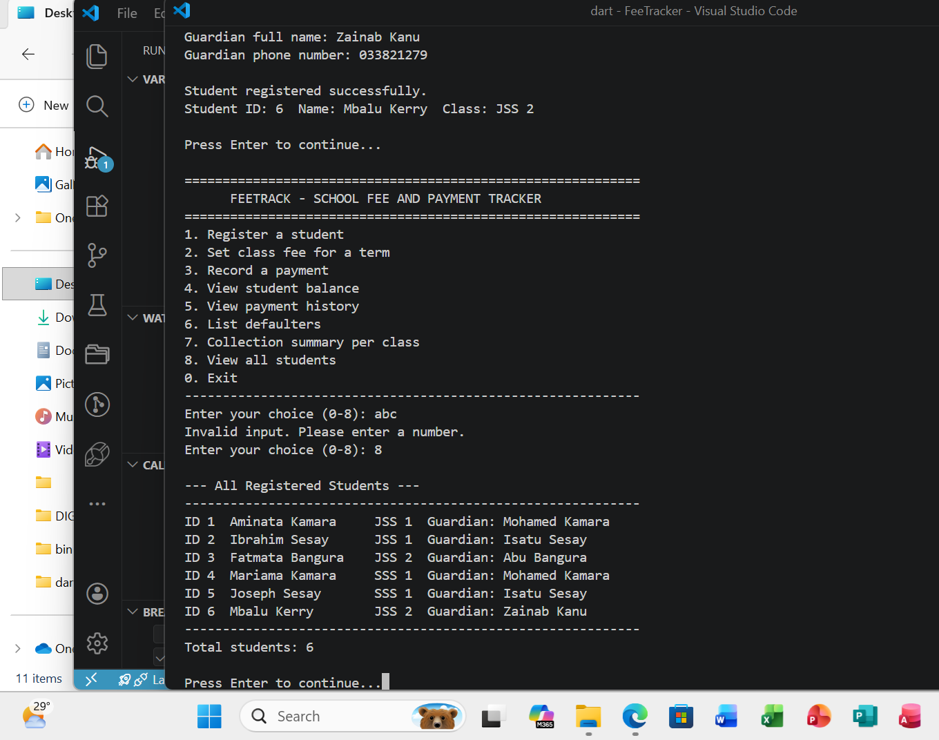
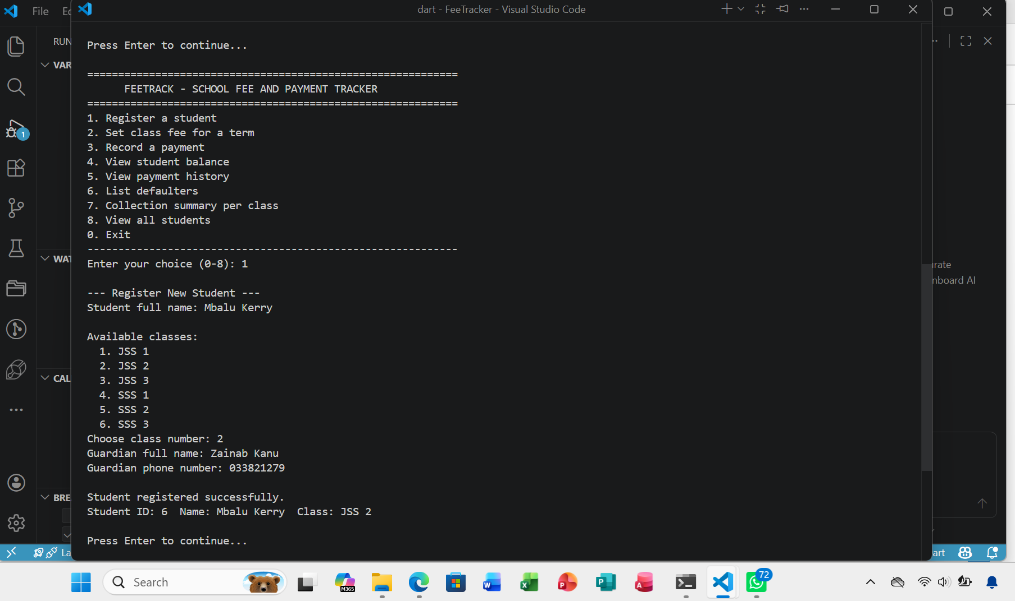
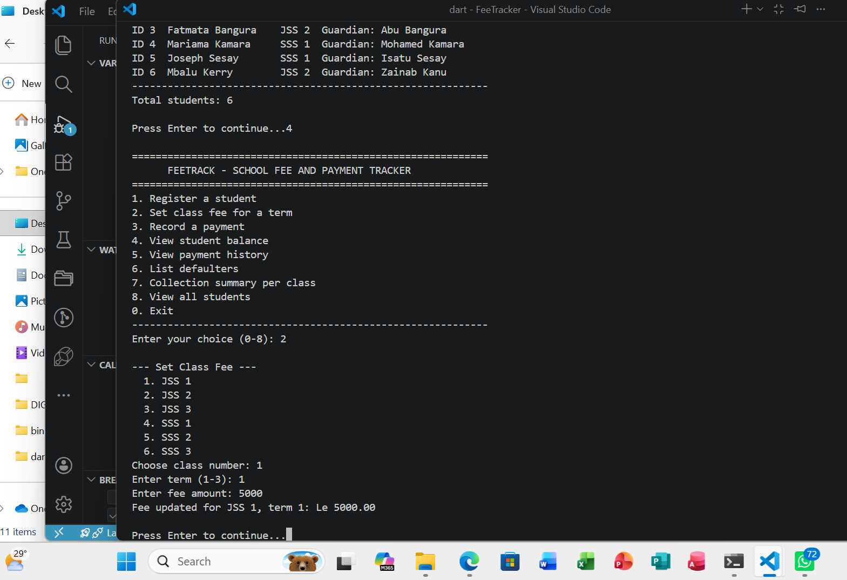

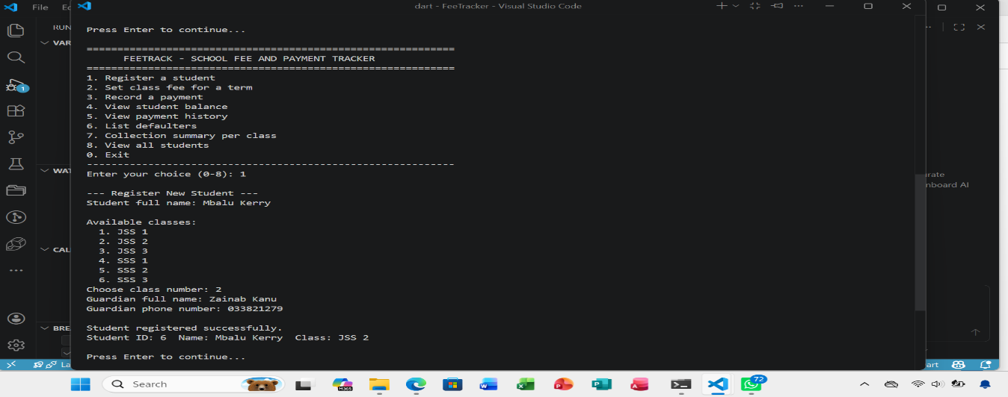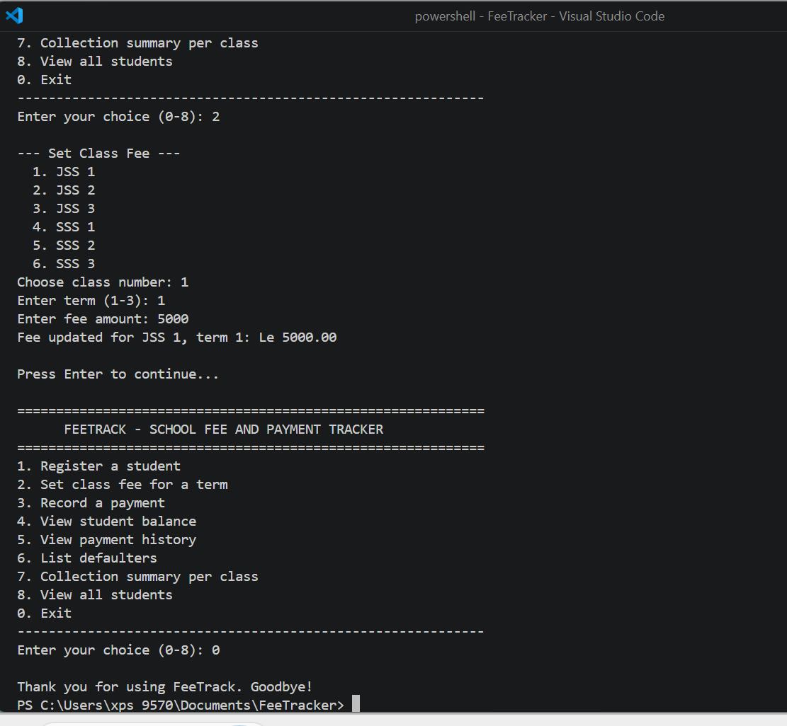

BRIEF EXPLANATION OF THE PROGRAM
FeeTrack is a console program that shows the main logic of the school fee system. When it starts, it loads sample data (6 classes, 5 students and 3 payments) and shows a menu with options 0 to 8. The program keeps running until the user chooses 0 to exit.
Classes. The program has five classes: Guardian, School Class, Student, Fee Structure and Payment.
Lists. Each class has a list (for example students and payments) that stores the objects while the program is running. The data is lost when the program closes, because no database is used at this stage.
Input and validation. The functions readInt, read Amount, read Name and read Phone use a loop to keep asking until the user enters a valid value. A letter instead of a number, a zero or negative amount, or a phone number with the wrong length is rejected. The program also checks that the student exists, that a fee has been set, and that a payment is not more than the balance.
Calculations. The function total Paid adds all payments made by a student in a term. The balance is the fee minus the total paid. The class summary calculates the expected amount (fee multiplied by the number of students), the amount collected, and the collection rate as a percentage. The function round Money keeps amounts to two decimal places.
Receipts. Each payment gets an automatic receipt number such as RCP-0001. After payment, the program prints a receipt showing the student, class, term, method, amount and new balance.
Menu options. The main function uses a while loop and a switch statement to call one function for each option: register a student, set a class fee, record a payment, view a balance, view payment history, list defaulters, show the class summary, and view all students. Limits of the prototype. It has no login and no permanent storage, and it does not include the parent view. These will be added in the Flutter and Supabase stages.
GITHUB REPOSITORY
The source code for this project is available on GitHub at:
https://github.com/Mbalu-kanu/FeeTracker--Dart-Prototype-
The repository is called fee track-dart-prototype. It contains:
- main. dart, the Dart console program
- README.md, which describes the project, its features and how to run it
To run the program, install the Dart SDK, download the repository, and type dart run main dart in the project folder.

CONCLUSION
This project identified a common problem in private secondary schools, which is manual fee recording, and proposed Fee Track to solve it. The Dart prototype shows the core logic: registering students, setting fees, recording payments, calculating balances, issuing receipts and listing defaulters. It has not been tested in a real school, so its benefits are expected and not measured. In Assignment 2 it will become a Flutter application, and in the final project a Supa base database will add permanent storage and login.

REFERENCES
Dart Team (n.d.) Dart documentation. Available at: https://dart.dev/guides (Accessed: [date]).
Flutter Team (n.d.) Flutter documentation. Available at: https://docs.flutter.dev (Accessed: [date]).
Sommerville, I. (2016) Software engineering. 10th edn. Harlow: Pearson.
Supabase (n.d.) Supabase documentation. Available at: https://supabase.com/docs (Accessed: [date]).

